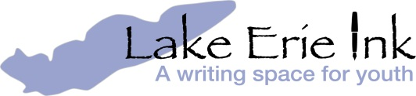

Thank you for supporting Lake Erie Ink. There are lots of ways your gift enriches young writers in our community:

______ $50……….Scholar – pays registration fee for one student to attend Lake Erie Ink for a quarter.

______ $125……..Underwriter – supplies enrichment programs for 25 participants.

______ $250……..Scribe –provides stipends for professional writers to work with student writers.

______ $500……..Publisher – promotes student writing with quality publications.

______ Free Thinker……Your gift of ______________ will support LEI in all of the above ways plus others we haven’t thought of yet.

We invite those who wish to contribute $1,000 or more to become a Founding Member of our new Inkwell Salon. You will provide a sustainable resource for young writers in our community and have access to exclusive gatherings featuring local adult and youth writers.
To find out how, call Amy Rosenbluth: 216-320-4757

*I would like to make my donation a multi-year gift. I pledge $____________ over the next ______ years.

______ Enclosed is my payment (check made payable to Lake Erie Ink)

______ I will donate online using my credit card (www.lakeerieink.org)

Name as you wish it to be listed on our donor page ___________________________________________

Street Address _____________________________________ City, State, __________________________

Zip__________________________ Email ____________________________________________

Phone_________________________________

If you do not wish to be publicly acknowledged please let us know and we will privately be very grateful.

Mail your donation to: Lake Erie Ink 2843 Washington Blvd. Cleveland Heights, OH 44118
www.lakeerieink.org | 216-320-4757
Lake Erie Ink is a 501(c)3 not-for-profit tax-exempt organization.

